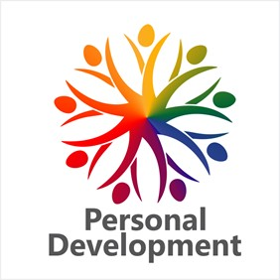

The Novalis Ubuntu Institute
Holistic Wellness Day 2016
‘Personal Development – A Pathway to Conscious Evolution’
Programme – Saturday, 15th October, 2016

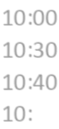10:00 Registration, Networking & Refreshments
10:30 Welcome: Anne-Lise Bure – Managing Director, The Novalis Ubuntu Institute
10:40 Programme for the day: Marianne Boulle, Marketing Manager, The Novalis Ubuntu Institute
10:45 Speaker One: Diana Smith – Hidden Mind Institute – The Hidden Mind Corrective Sound
Protocol
11:00 Speaker Two: Liesl Viljoen and Karin Liebenberg – Health Coach SA – Key Concepts to Health and Happiness – The Integrative Nutrition Way
11:15 Feedback Break
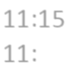11:33 Guest Speaker – Anthony Rees - National Chairman of the Traditional and Natural Health
Alliance ‘Unnatural Regulations for Natural Health Products’ An overview and update
11:55 A Chance for Every Child Presentation: Bea Juries – Community Development Manager, A Chance for Every Child Project, The Novalis Ubuntu Institute
12:08 Speaker Three: Loraine Magda – Noetic Business Coaching – Thriving By Balancing Your Inner
Masculine and Feminine
12:23 Speaker Four: Amy Kaye – Write On South Africa – Writing As Therapy: Using Writing as a
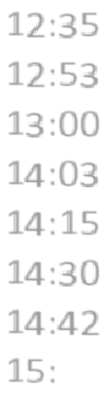Creative Tool for Healing
12:37 Feedback Break
12:53 Personal Development Programme 2017: Marianne Boulle
13:00 Lunch
14:03 An interview with Estelle Moys - Owner and Editor of Link-Up Western Cape
14:15 Speaker Five: Corne MacKenzie - Restless and Aware – Embracing Mid-Life
14:30 Speaker Six: Naett Atkinson – Financial Confidence, Financial Wellness
14:42 Feedback Break
15:02 A Message from Our Partners, Sofia Association, Sweden: Bea Juries.
Appreciation: Naren Sewpaul – Organisation Development Manager, The Novalis Ubuntu
Institute
15:15 Closing with further networking until 15:30

Speaker’s gifts were kindly provided by Beaucience - ‘Using science to harness the benefits of nature.'
Today’s photographer is Roxanne Kotze Photography – ‘Making memories last forever.’

